Azure tour

Search resource, Services, and docs

Cloud shell

Directory and Subscription
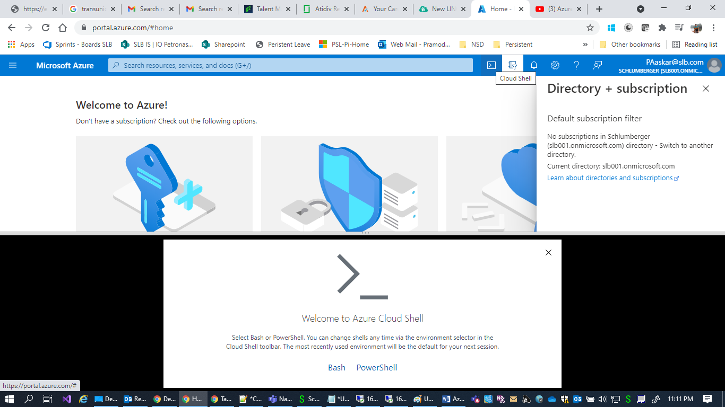

Notification
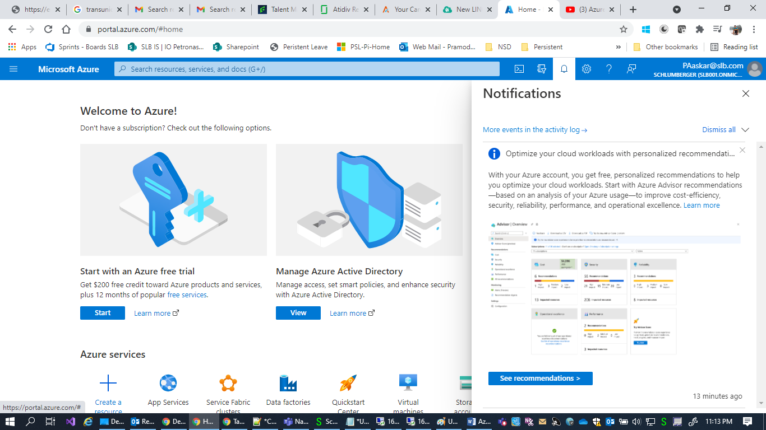

Portal Settings
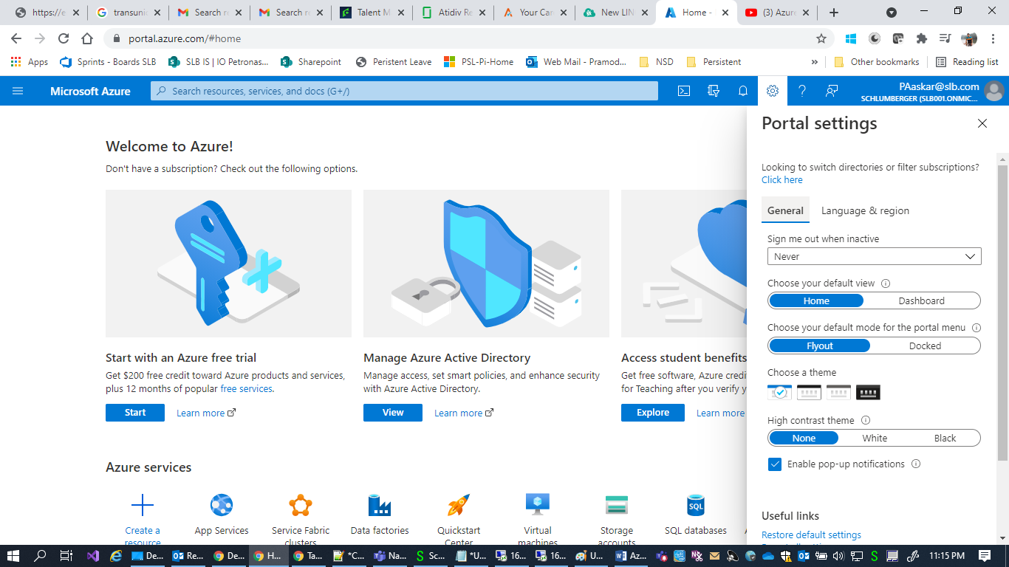

Help
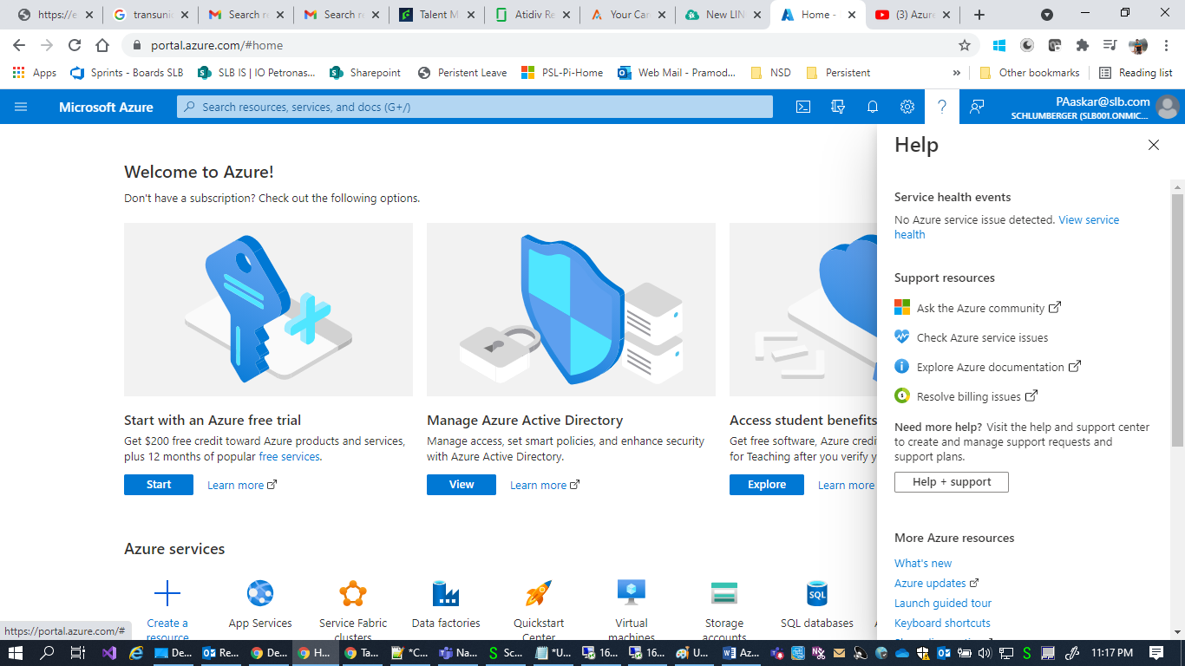

Send feedback to Microsoft
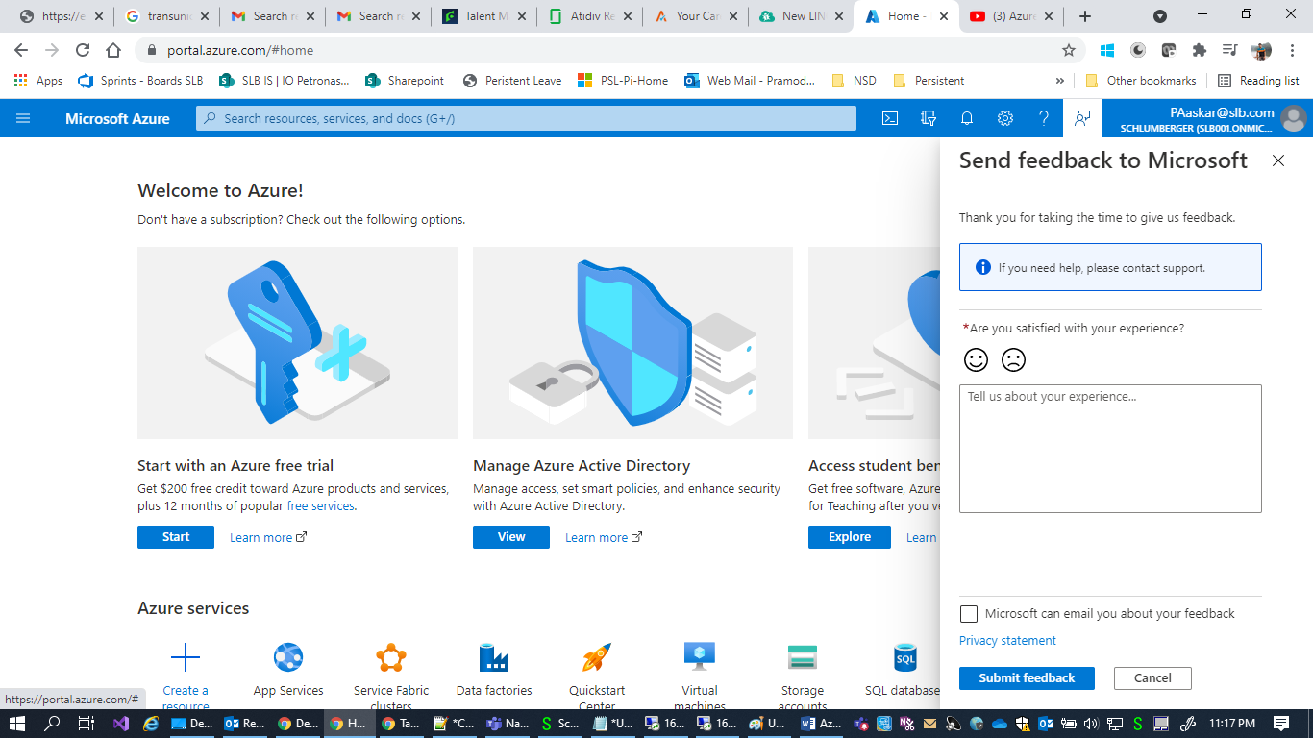

Account Icon
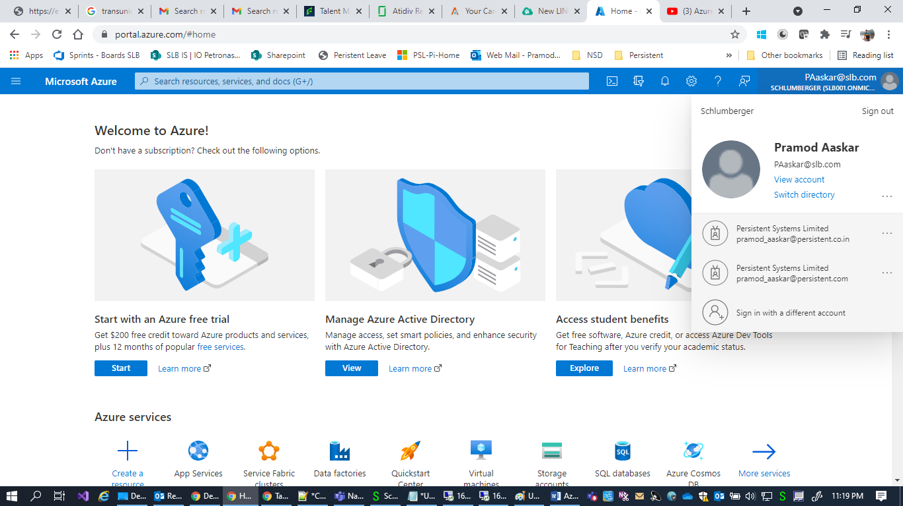

Left Menu

List of services and component
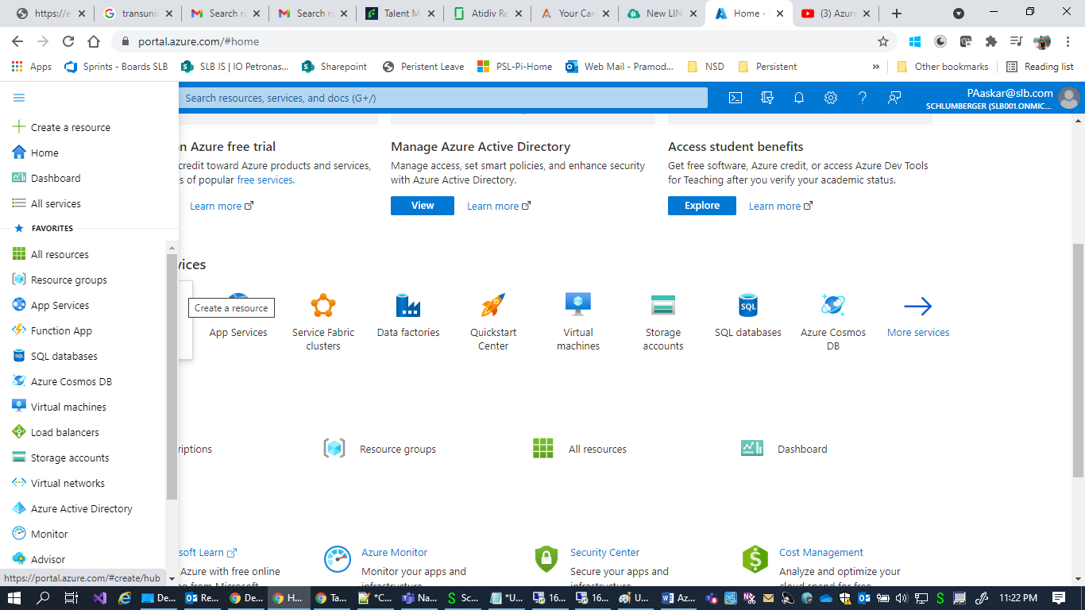

Quick Start center

Start a project
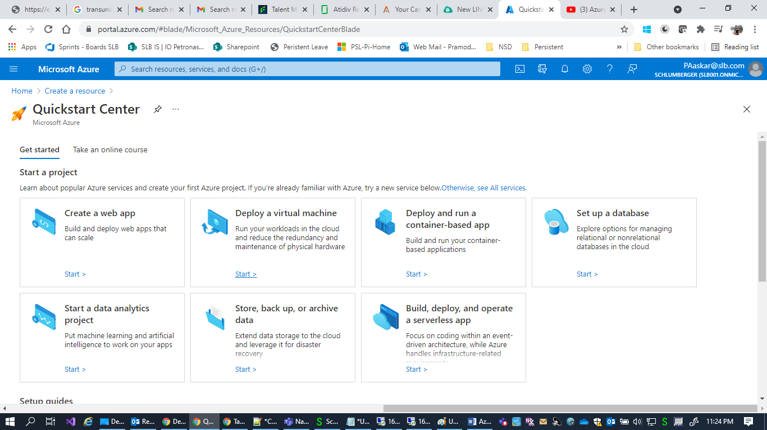

SetUp Guides
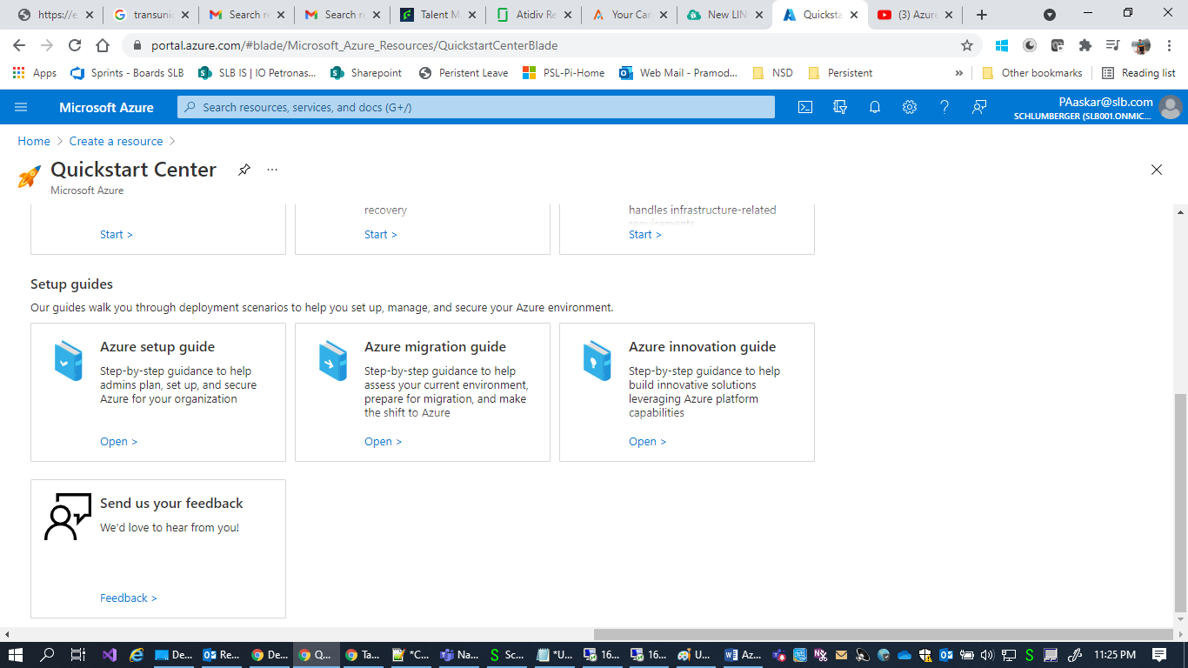

Create Resource

Create resource has below options

Windows Servier 2019 DataCenter :

Ubuntu Server 20.04 LTS

Web App

SQL Database

Function App

Azure Cosmos DB

Kubernates Service

Devops Starter

Storage Account
